DIGITAL DESIGN PROJECT

ECE 287

**VHDL GUITAR HERO**

MARGUERITE SMITH

RYAN CAMPBELL

DECEMBER 3, 2021

MIAMI UNIVERSITY

OXFORD, OH



**Project Overview**

The first step of the project was to get the VGA working and connected to our programs. After about a week of trial and error, the VGA was working and responsive. The most prominent and universally recognizable visual aspect of Guitar Hero is the large rectangular guitar neck spanning from the top of the screen to the bottom. This neck has four equal sized vertical sections for different colored notes. The images below are the initial images of the guitar neck on the screen created with modified VGA VHDL. 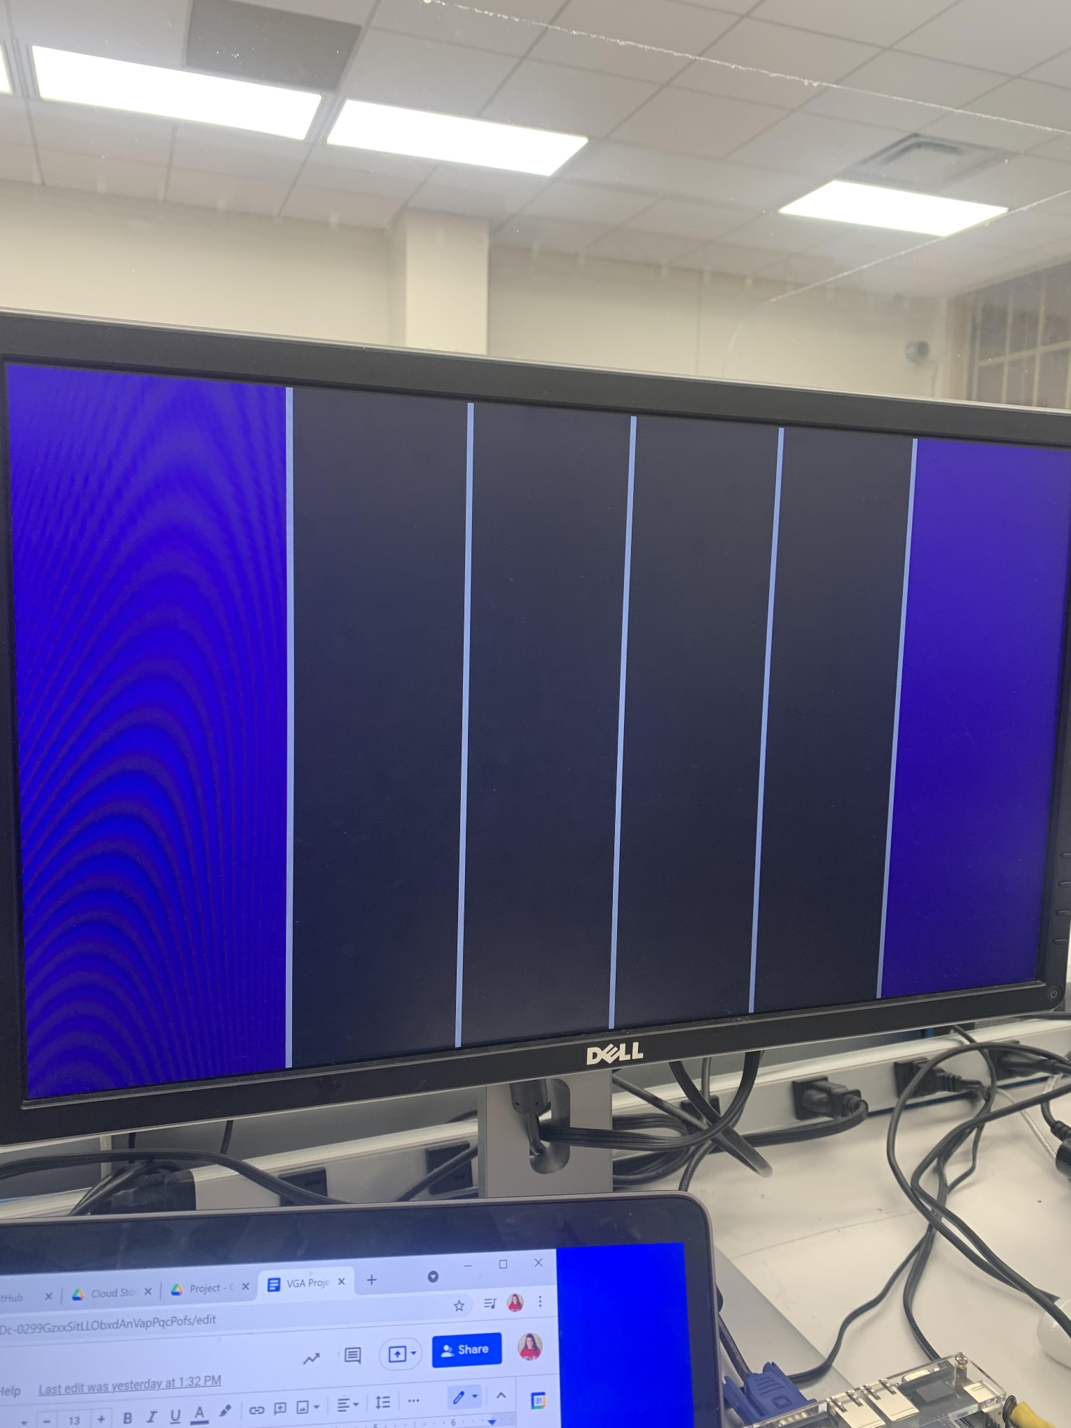

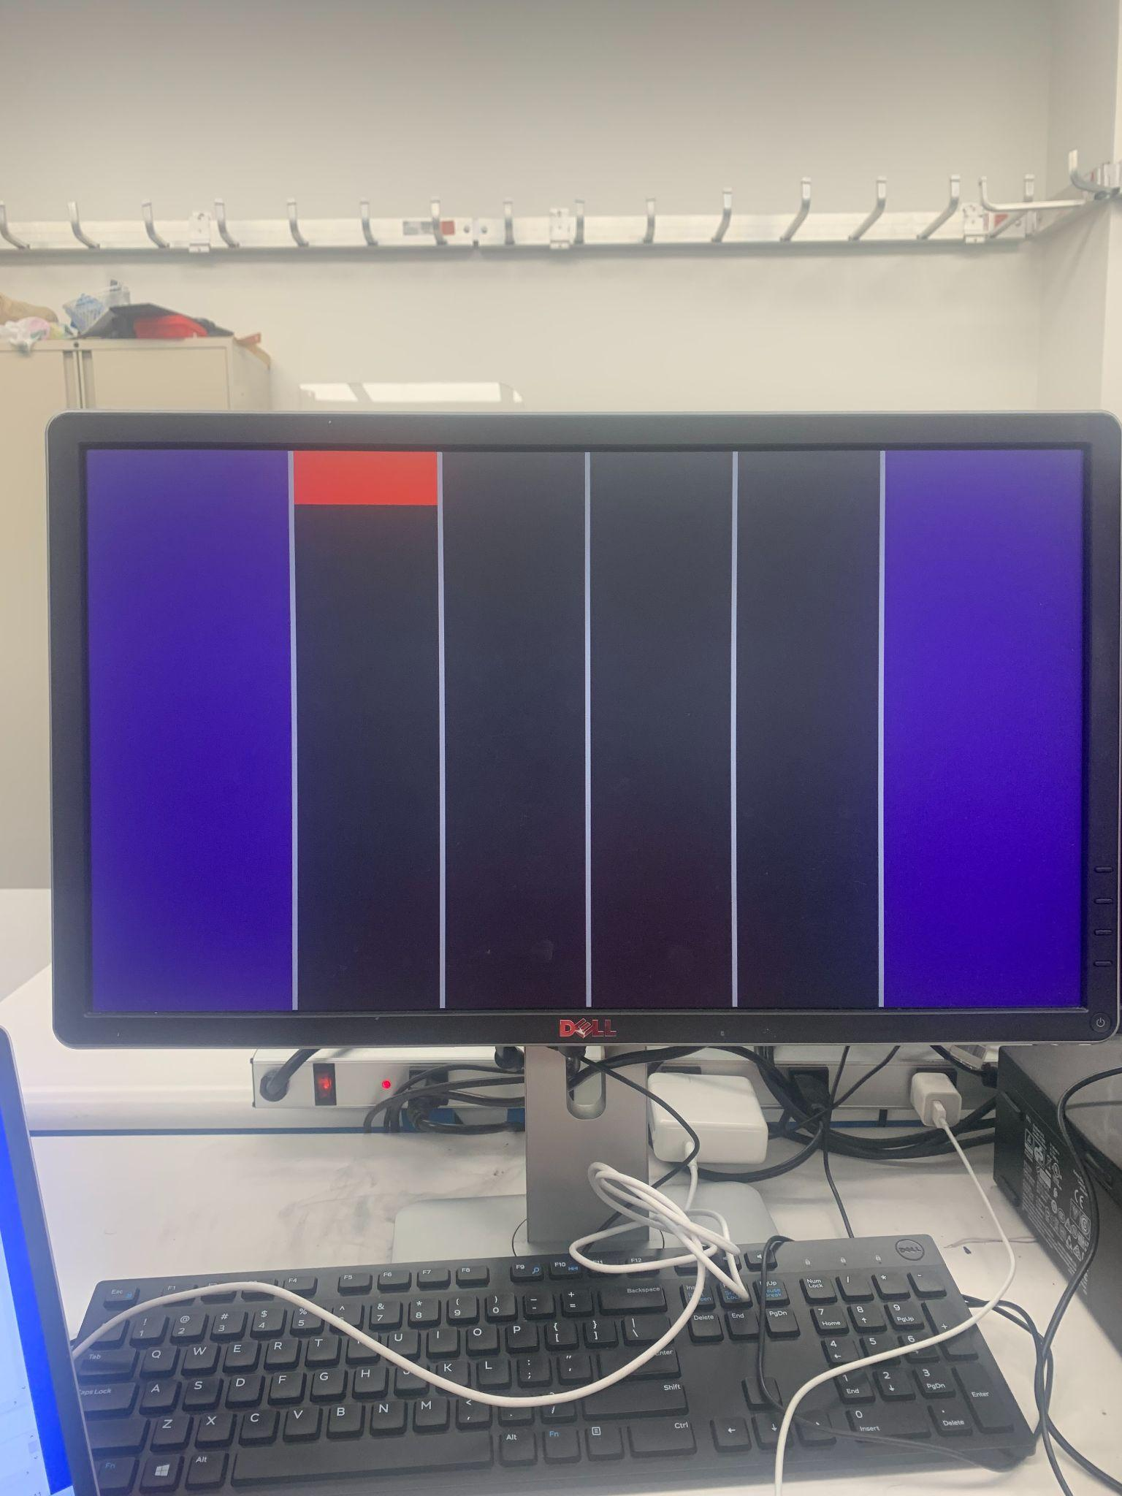

The next step was object motion on the VGA, which in the case of Guitar Hero means vertical motion down the screen. Each of the four columns has a different note color. Arranging the falling notes in certain patterns represents different songs. The note pattern used follows the tune of the ABCs. Adjusting the speed that the notes fall was necessary to replicate a convincing song pattern. Note spacing was also taken into consideration and updated frequently to match the style and pace of the song. Each note starts at the stop of the screen and takes a few seconds to reach the bottom of the screen where there are two horizontal bars that act as a threshold. The correct push button must be pressed while the note is within the two grey bars to score a point. 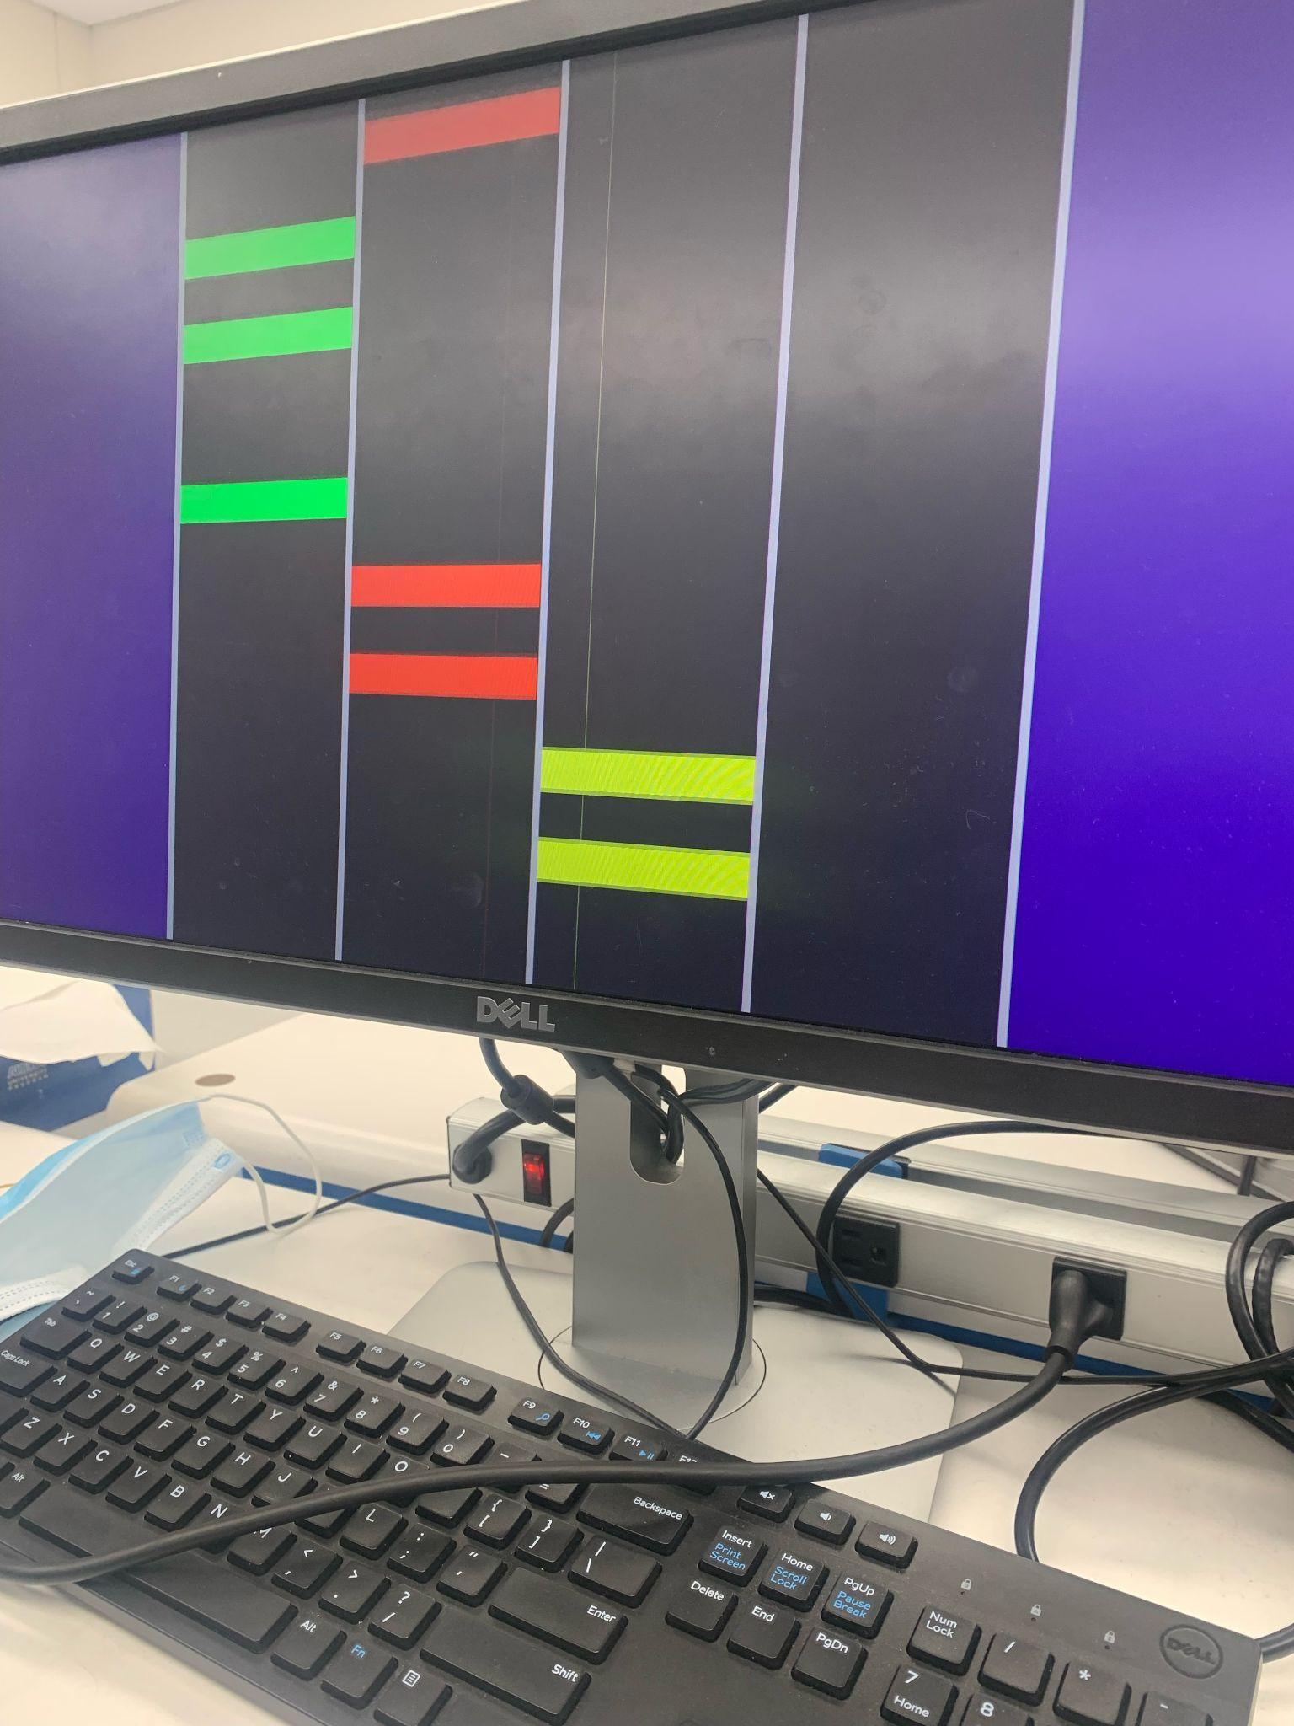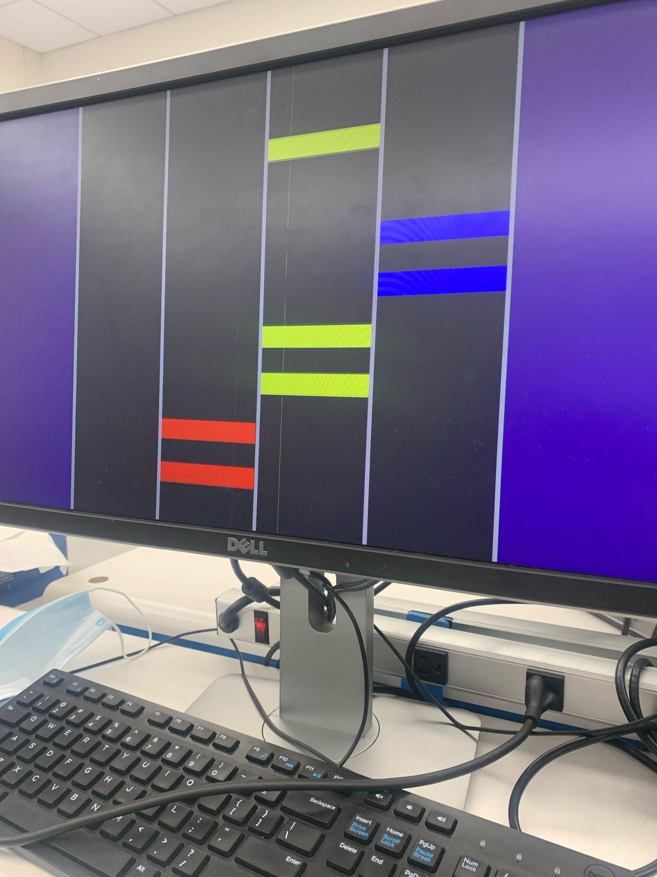

An introduction screen was an additional feature added to the project that was not initially planned. This screen serves as an introduction to the game and is controlled by SW0 on the board. When the switch is flipped, the menu screen disappears and the game will start. The four push button switches on the board control a column of the guitar neck. When a note is between two grey threshold lines at the bottom of the screen, the user pushes the respective button. If successful, they add one point to their score which is shown by the two digit 7 segment display. Scoring 100% accuracy on the song will result in a perfect maximum score of 26. Each button needed to be debounced to match the score on the 7 segment display, and then adjusted to only add to the score when the button is pressed while a note is in its threshold. If a note is missed or pressed incorrectly, you lose a point instead of gaining one. 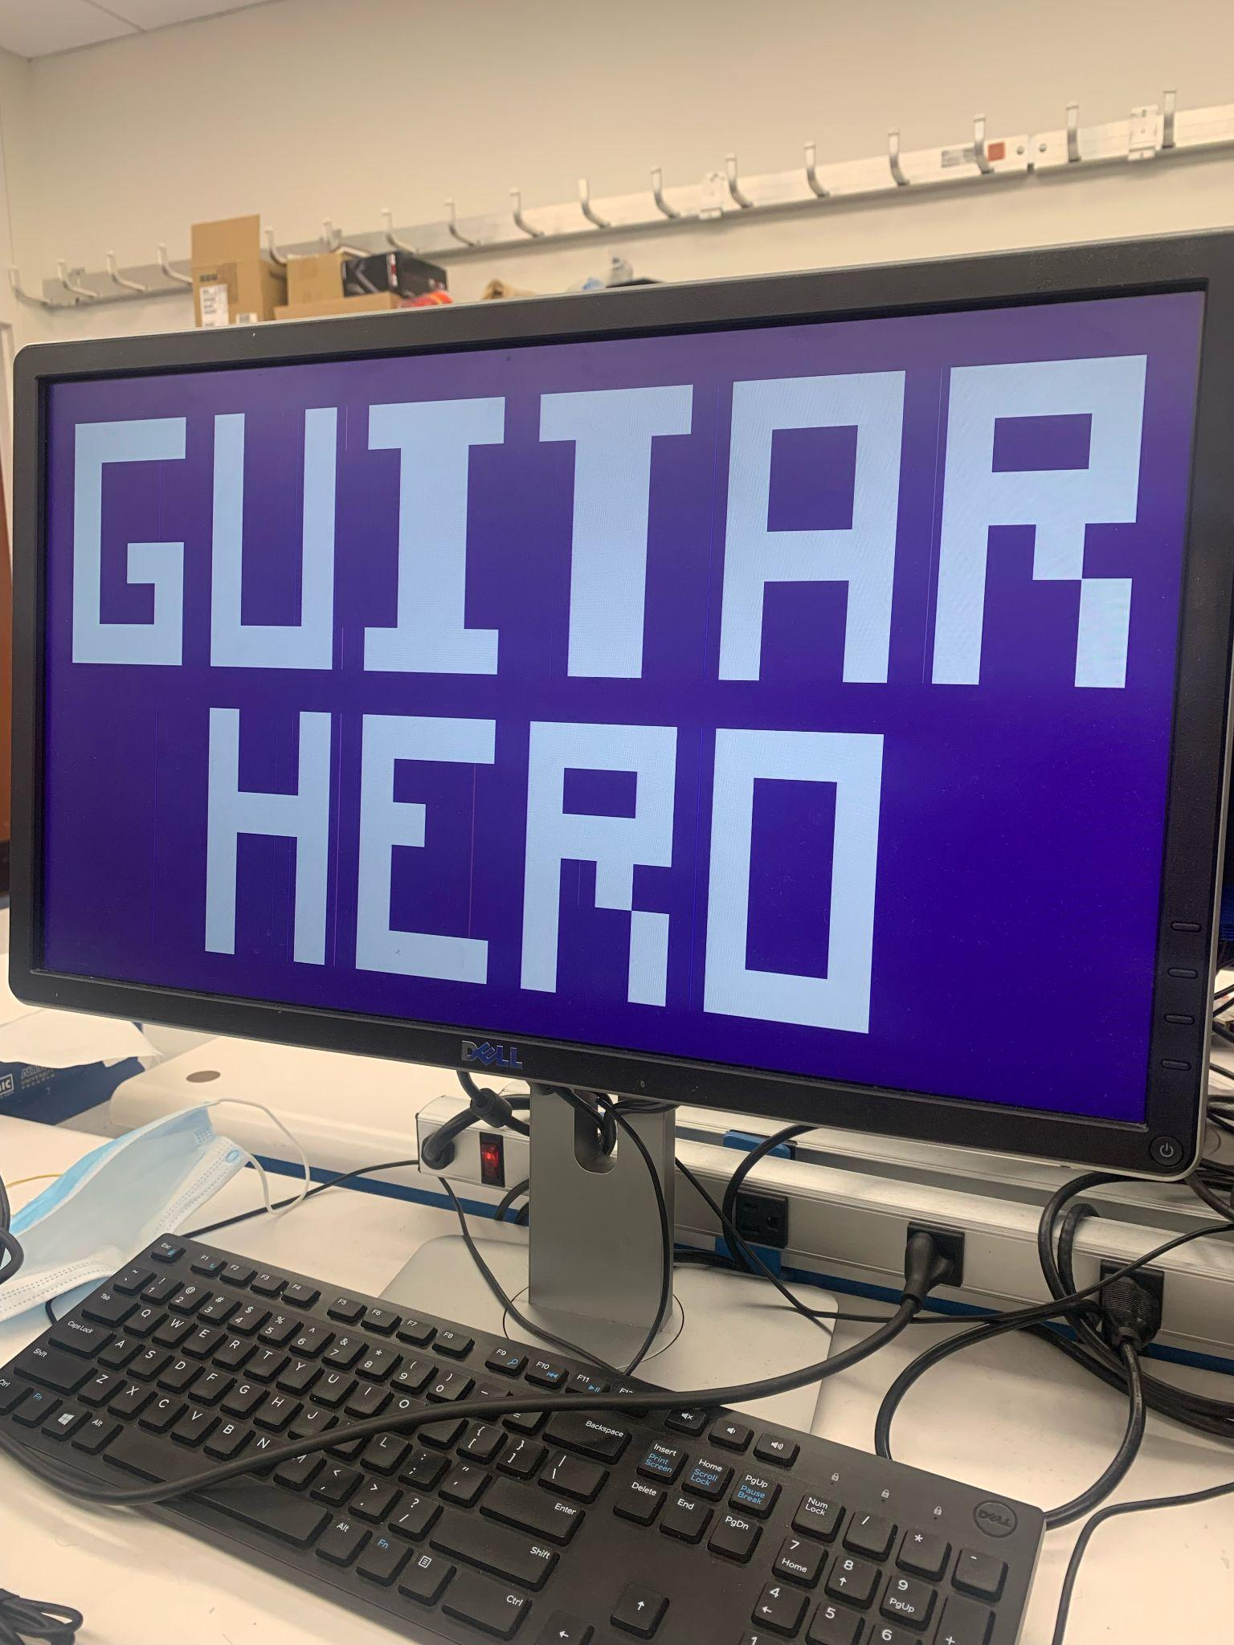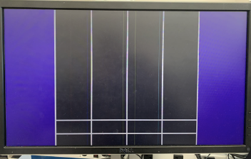

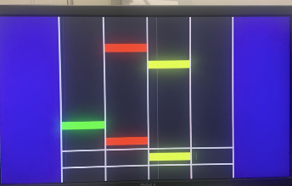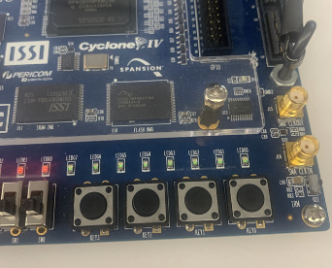

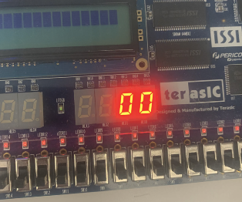

**Github Link**

[**https://github.com/RyanCampbell152/GuitarHero_VHDL**](https://github.com/RyanCampbell152/GuitarHero_VHDL)

**Youtube Video Link**

[**https://youtu.be/QmWoFfy1oiU**](https://youtu.be/QmWoFfy1oiU)

**Gantt Chart**

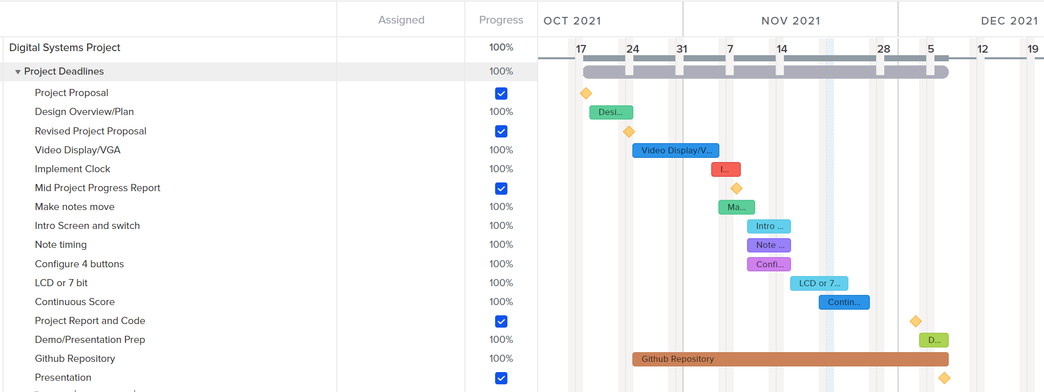

**Project Operation**

The game opens to the Guitar Hero introduction screen and the score displays 00. To start the game, the first switch SW0 needs to be flipped. Next, the notes will start to approach the threshold gray bars at the bottom of the screen to the tune and pattern of the ABCs. While the notes are within the threshold, the respective button needs to be pressed in order to gain points and add to the score. If a note is pressed incorrectly, one point is subtracted from the score. A perfect score would be 26. If no buttons are pressed, the score will not change. When the game concludes, it can be restarted by flipping the introduction screen switch and starting the game and score over so that the user can play an infinite amount of times.

* Features completely working
  + Title screen
  + Game screen, notes and their movement
  + Score Display (seven segment display)
* Features partially working
  + Menu switch
    - When you flip the switch very fast multiple times often notes will disappear from the game screen
  + Buttons (specifically debouncing)
    - Might still be possible to hit the button multiple times within a note

**Future Suggestions**

Future versions of the project should implement some kind of music or sound to accompany the game. The auditory feature of the game is an important one that could not be included during the span of this project but would increase the complexity and accuracy of the game as compared to the real Guitar Hero video game. Other more feasible additions could be additional levels with different songs connected to different switches or changes in difficulty of song choices. Also, use of the LCD to display song titles or other messages would add a new level of detail for the user.

**Appendix**

**VGA_Controller.vhd**

LIBRARY ieee;

USE ieee.std_logic_1164.all;

ENTITY vga_controller IS

GENERIC(

h_pulse : INTEGER := 208; --horiztonal sync pulse width in pixels

h_bp : INTEGER := 336; --horiztonal back porch width in pixels

h_pixels : INTEGER := 1920; --horiztonal display width in pixels

h_fp : INTEGER := 128; --horiztonal front porch width in pixels

h_pol : STD_LOGIC := '0'; --horizontal sync pulse polarity (1 = positive, 0 = negative)

v_pulse : INTEGER := 3; --vertical sync pulse width in rows

v_bp : INTEGER := 38; --vertical back porch width in rows

v_pixels : INTEGER := 1080; --vertical display width in rows

v_fp : INTEGER := 1; --vertical front porch width in rows

v_pol : STD_LOGIC := '1'); --vertical sync pulse polarity (1 = positive, 0 = negative)

PORT(

pixel_clk : IN STD_LOGIC; --pixel clock at frequency of VGA mode being used

reset_n : IN STD_LOGIC; --active low asycnchronous reset

h_sync : OUT STD_LOGIC; --horiztonal sync pulse

v_sync : OUT STD_LOGIC; --vertical sync pulse

disp_ena : OUT STD_LOGIC; --display enable ('1' = display time, '0' = blanking time)

column : OUT INTEGER; --horizontal pixel coordinate

row : OUT INTEGER; --vertical pixel coordinate

n_blank : OUT STD_LOGIC; --direct blacking output to DAC

n_sync : OUT STD_LOGIC); --sync-on-green output to DAC

END vga_controller;

ARCHITECTURE behavior OF vga_controller IS

CONSTANT h_period : INTEGER := h_pulse + h_bp + h_pixels + h_fp; --total number of pixel clocks in a row

CONSTANT v_period : INTEGER := v_pulse + v_bp + v_pixels + v_fp; --total number of rows in column

BEGIN

n_blank <= '1'; --no direct blanking

n_sync <= '0'; --no sync on green

PROCESS(pixel_clk, reset_n)

VARIABLE h_count : INTEGER RANGE 0 TO h_period - 1 := 0; --horizontal counter (counts the columns)

VARIABLE v_count : INTEGER RANGE 0 TO v_period - 1 := 0; --vertical counter (counts the rows)

BEGIN

IF(reset_n = '0') THEN --reset asserted

h_count := 0; --reset horizontal counter

v_count := 0; --reset vertical counter

h_sync <= NOT h_pol; --deassert horizontal sync

v_sync <= NOT v_pol; --deassert vertical sync

disp_ena <= '0'; --disable display

column <= 0; --reset column pixel coordinate

row <= 0; --reset row pixel coordinate

ELSIF(pixel_clk'EVENT AND pixel_clk = '1') THEN

--counters

IF(h_count < h_period - 1) THEN --horizontal counter (pixels)

h_count := h_count + 1;

ELSE

h_count := 0;

IF(v_count < v_period - 1) THEN --veritcal counter (rows)

v_count := v_count + 1;

ELSE

v_count := 0;

END IF;

END IF;

--horizontal sync signal

IF(h_count < h_pixels + h_fp OR h_count >= h_pixels + h_fp + h_pulse) THEN

h_sync <= NOT h_pol; --deassert horiztonal sync pulse

ELSE

h_sync <= h_pol; --assert horiztonal sync pulse

END IF;

--vertical sync signal

IF(v_count < v_pixels + v_fp OR v_count >= v_pixels + v_fp + v_pulse) THEN

v_sync <= NOT v_pol; --deassert vertical sync pulse

ELSE

v_sync <= v_pol; --assert vertical sync pulse

END IF;

--set pixel coordinates

IF(h_count < h_pixels) THEN --horiztonal display time

column <= h_count; --set horiztonal pixel coordinate

END IF;

IF(v_count < v_pixels) THEN --vertical display time

row <= v_count; --set vertical pixel coordinate

END IF;

--set display enable output

IF(h_count < h_pixels AND v_count < v_pixels) THEN --display time

disp_ena <= '1'; --enable display

ELSE --blanking time

disp_ena <= '0'; --disable display

END IF;

END IF;

END PROCESS;

END behavior;

**Hw_image_generator.vhd**

LIBRARY ieee;

USE ieee.std_logic_1164.all;

use IEEE.STD_LOGIC_ARITH.all;

use IEEE.STD_LOGIC_UNSIGNED.all;

use ieee.numeric_std.all;

ENTITY hw_image_generator IS

GENERIC(

pixels_y10: INTEGER := 1536;

pixels_y9: INTEGER := 1526;

pixels_y8: INTEGER := 1251;

pixels_y7: INTEGER := 1241;

pixels_y6: INTEGER := 965;

pixels_y5: INTEGER := 955;

pixels_y4: INTEGER := 679;

pixels_y3: INTEGER := 669;

pixels_y2: INTEGER := 394;

pixels_y : INTEGER := 384 );

PORT(

greenBut : IN STD_LOGIC;

redBut : IN STD_LOGIC;

yellowBut : IN STD_LOGIC;

blueBut : IN STD_LOGIC;

Menu_sw : IN STD_LOGIC;

CLK_50MHz : IN STD_LOGIC;

disp_ena : IN STD_LOGIC; --display enable ('1' = display time, '0' = blanking time)

row : IN INTEGER; --row pixel coordinate

column : IN INTEGER; --column pixel coordinate

red : OUT STD_LOGIC_VECTOR(7 DOWNTO 0) := (OTHERS => '0'); --red magnitude output to DAC

green : OUT STD_LOGIC_VECTOR(7 DOWNTO 0) := (OTHERS => '0'); --green magnitude output to DAC

blue : OUT STD_LOGIC_VECTOR(7 DOWNTO 0) := (OTHERS => '0'); --blue magnitude output to DAC

s : OUT STD_LOGIC_VECTOR(4 DOWNTO 0) := (OTHERS => '0')); --seven segment display output

END hw_image_generator;

ARCHITECTURE behavior OF hw_image_generator IS

signal counter : std_logic_vector(24 downto 0); --signal for counting

------------------------------------------------------------- Green Note Thresholds

signal green_1 : INTEGER := -1510;

signal green_2 : INTEGER := -1620;

signal green_3 : INTEGER := -1730;

signal green_4 : INTEGER := -1950;

signal green_5 : INTEGER := -2570;

signal green_6 : INTEGER := -3190;

signal green_7 : INTEGER := -3990;

signal green_8 : INTEGER := -4190;

------------------------------------------------------------- Red Note Thresholds

signal red_1 : INTEGER := 0;

signal red_2 : INTEGER := -110;

signal red_3 : INTEGER := -1190;

signal red_4 : INTEGER := -1300;

signal red_5 : INTEGER := -1840;

signal red_6 : INTEGER := -2360;

signal red_7 : INTEGER := -2980;

signal red_8 : INTEGER := -3690;

------------------------------------------------------------- Yellow Note Thresholds

signal yellow_1 : INTEGER := -230;

signal yellow_2 : INTEGER := -340;

signal yellow_3 : INTEGER := -670;

signal yellow_4 : INTEGER := -970;

signal yellow_5 : INTEGER := -1080;

signal yellow_6 : INTEGER := -2250;

signal yellow_7 : INTEGER := -2870;

signal yellow_8 : INTEGER := -3590;

------------------------------------------------------------- Blue Note thresholds

signal blue_1 : INTEGER := -450;

signal blue_2 : INTEGER := -560;

-------------------------------------------------------------

signal noteWidth : INTEGER := 50; -- Width of all notes

signal currScore : std_logic_vector(3 downto 0) := (OTHERS => '0'); -- Score of the player

signal add1 : INTEGER := 1; -- Value that output "s" increments by

signal greenBut_debounced : STD_LOGIC := '0'; -- Green button debouncing signal

signal redBut_debounced : STD_LOGIC := '0'; -- Red button debouncing signal

signal yellowBut_debounced : STD_LOGIC := '0'; -- Yellow button debouncing signal

signal blueBut_debounced : STD_LOGIC := '0'; -- Blue button debouncing signal

signal key_pressed : STD_LOGIC := '0';

BEGIN

ABC: PROCESS(disp_ena, row, column, CLK_50MHz) --Displays menu and game

BEGIN

IF(disp_ena = '1' AND Menu_sw = '1') THEN --Display game

IF(row < pixels_y) THEN --purple

red <= "01001101";

green <= "00000001";

blue <= "10001100";

ELSIF (row < pixels_y2) THEN --white

red <= "11001010";

green <= "10110100";

blue <= "10110100";

ELSIF (row < pixels_y3 and ((column >= 870 and column < 880) or (column >= 980 and column < 990))) THEN --white bar

red <= "11001010";

green <= "10110100";

blue <= "10110100";

ELSIF(row < pixels_y3 - 1 AND column >= green_1 AND column < green_1 + noteWidth) THEN --Begin Green Notes

red <= (OTHERS => '0');

green <= (OTHERS => '1');

blue <= (OTHERS => '0');

ELSIF(row < pixels_y3 - 1 AND column >= green_2 AND column < green_2 + noteWidth) THEN

red <= (OTHERS => '0');

green <= (OTHERS => '1');

blue <= (OTHERS => '0');

ELSIF(row < pixels_y3 - 1 AND column >= green_3 AND column < green_3 + noteWidth) THEN

red <= (OTHERS => '0');

green <= (OTHERS => '1');

blue <= (OTHERS => '0');

ELSIF(row < pixels_y3 - 1 AND column >= green_4 AND column < green_4 + noteWidth) THEN

red <= (OTHERS => '0');

green <= (OTHERS => '1');

blue <= (OTHERS => '0');

ELSIF(row < pixels_y3 - 1 AND column >= green_5 AND column < green_5 + noteWidth) THEN

red <= (OTHERS => '0');

green <= (OTHERS => '1');

blue <= (OTHERS => '0');

ELSIF(row < pixels_y3 - 1 AND column >= green_6 AND column < green_6 + noteWidth) THEN

red <= (OTHERS => '0');

green <= (OTHERS => '1');

blue <= (OTHERS => '0');

ELSIF(row < pixels_y3 - 1 AND column >= green_7 AND column < green_7 + noteWidth) THEN

red <= (OTHERS => '0');

green <= (OTHERS => '1');

blue <= (OTHERS => '0');

ELSIF(row < pixels_y3 - 1 AND column >= green_8 AND column < green_8 + noteWidth) THEN --End Green Notes

red <= (OTHERS => '0');

green <= (OTHERS => '1');

blue <= (OTHERS => '0');

ELSIF (row < pixels_y3) THEN --dark purple

red <= "00101111";

green <= "00101001";

blue <= "00110011";

ELSIF (row < pixels_y4) THEN --white

red <= "11001010";

green <= "10110100";

blue <= "10110100";

ELSIF (row < pixels_y5 and ((column >= 870 and column < 880) or (column >= 980 and column < 990))) THEN --white bar

red <= "11001010";

green <= "10110100";

blue <= "10110100";

ELSIF(row < pixels_y5 - 1 AND column >= red_1 AND column < red_1 + noteWidth) THEN --Begin Red Notes

red <= (OTHERS => '1');

green <= (OTHERS => '0');

blue <= (OTHERS => '0');

ELSIF(row < pixels_y5 - 1 AND column >= red_2 AND column < red_2 + noteWidth) THEN

red <= (OTHERS => '1');

green <= (OTHERS => '0');

blue <= (OTHERS => '0');

ELSIF(row < pixels_y5 - 1 AND column >= red_3 AND column < red_3 + noteWidth) THEN

red <= (OTHERS => '1');

green <= (OTHERS => '0');

blue <= (OTHERS => '0');

ELSIF(row < pixels_y5 - 1 AND column >= red_4 AND column < red_4 + noteWidth) THEN

red <= (OTHERS => '1');

green <= (OTHERS => '0');

blue <= (OTHERS => '0');

ELSIF(row < pixels_y5 - 1 AND column >= red_5 AND column < red_5 + noteWidth) THEN

red <= (OTHERS => '1');

green <= (OTHERS => '0');

blue <= (OTHERS => '0');

ELSIF(row < pixels_y5 - 1 AND column >= red_6 AND column < red_6 + noteWidth) THEN

red <= (OTHERS => '1');

green <= (OTHERS => '0');

blue <= (OTHERS => '0');

ELSIF(row < pixels_y5 - 1 AND column >= red_7 AND column < red_7 + noteWidth) THEN

red <= (OTHERS => '1');

green <= (OTHERS => '0');

blue <= (OTHERS => '0');

ELSIF(row < pixels_y5 - 1 AND column >= red_8 AND column < red_8 + noteWidth) THEN --End Red Notes

red <= (OTHERS => '1');

green <= (OTHERS => '0');

blue <= (OTHERS => '0');

ELSIF (row < pixels_y5) THEN --dark purple

red <= "00101111";

green <= "00101001";

blue <= "00110011";

ELSIF (row < pixels_y6) THEN --white

red <= "11001010";

green <= "10110100";

blue <= "10110100";

ELSIF (row < pixels_y7 and ((column >= 870 and column < 880) or (column >= 980 and column < 990))) THEN --white bar

red <= "11001010";

green <= "10110100";

blue <= "10110100";

ELSIF(row < pixels_y7 - 1 AND column >= yellow_1 AND column < yellow_1 + noteWidth) THEN --Begin Yellow Notes

red <= (OTHERS => '1');

green <= (OTHERS => '1');

blue <= (OTHERS => '0');

ELSIF(row < pixels_y7 - 1 AND column >= yellow_2 AND column < yellow_2 + noteWidth) THEN

red <= (OTHERS => '1');

green <= (OTHERS => '1');

blue <= (OTHERS => '0');

ELSIF(row < pixels_y7 - 1 AND column >= yellow_3 AND column < yellow_3 + noteWidth) THEN

red <= (OTHERS => '1');

green <= (OTHERS => '1');

blue <= (OTHERS => '0');

ELSIF(row < pixels_y7 - 1 AND column >= yellow_4 AND column < yellow_4 + noteWidth) THEN

red <= (OTHERS => '1');

green <= (OTHERS => '1');

blue <= (OTHERS => '0');

ELSIF(row < pixels_y7 - 1 AND column >= yellow_5 AND column < yellow_5 + noteWidth) THEN

red <= (OTHERS => '1');

green <= (OTHERS => '1');

blue <= (OTHERS => '0');

ELSIF(row < pixels_y7 - 1 AND column >= yellow_6 AND column < yellow_6 + noteWidth) THEN

red <= (OTHERS => '1');

green <= (OTHERS => '1');

blue <= (OTHERS => '0');

ELSIF(row < pixels_y7 - 1 AND column >= yellow_7 AND column < yellow_7 + noteWidth) THEN

red <= (OTHERS => '1');

green <= (OTHERS => '1');

blue <= (OTHERS => '0');

ELSIF(row < pixels_y7 - 1 AND column >= yellow_8 AND column < yellow_8 + noteWidth) THEN --End Yellow Notes

red <= (OTHERS => '1');

green <= (OTHERS => '1');

blue <= (OTHERS => '0');

ELSIF (row < pixels_y7) THEN --dark purple

red <= "00101111";

green <= "00101001";

blue <= "00110011";

ELSIF (row < pixels_y8) THEN --white

red <= "11001010";

green <= "10110100";

blue <= "10110100";

ELSIF (row < pixels_y9 and ((column >= 870 and column < 880) or (column >= 980 and column < 990))) THEN --white bar

red <= "11001010";

green <= "10110100";

blue <= "10110100";

ELSIF(row < pixels_y9 - 1 AND column >= blue_1 AND column < blue_1 + noteWidth) THEN --Begin Blue Notes

red <= (OTHERS => '0');

green <= (OTHERS => '0');

blue <= (OTHERS => '1');

ELSIF(row < pixels_y9 - 1 AND column >= blue_2 AND column < blue_2 + noteWidth) THEN --End Blue Notes

red <= (OTHERS => '0');

green <= (OTHERS => '0');

blue <= (OTHERS => '1');

ELSIF (row < pixels_y9) THEN --dark purple

red <= "00101111";

green <= "00101001";

blue <= "00110011";

ELSIF (row < pixels_y10) THEN --white

red <= "11001010";

green <= "10110100";

blue <= "10110100";

ELSIF (row >= pixels_y10) THEN --purple

red <= "01001101";

green <= "00000001";

blue <= "10001100";

ELSE

red <= (OTHERS => '0');

green <= (OTHERS => '0');

blue <= (OTHERS => '0');

END IF;

ELSE --blanking time

red <= (OTHERS => '0');

green <= (OTHERS => '0');

blue <= (OTHERS => '0');

END IF;

IF(disp_ena = '1' AND Menu_sw = '0') THEN --Display menu

if (row >= 62 AND row < 124 AND column > 72 AND column < 504) then --G begin

red <= (OTHERS => '1');

green <= (OTHERS => '1');

blue <= (OTHERS => '1');

elsif (row >= 124 AND row < 186 AND ((column > 72 AND column < 144) OR (column > 432 AND column < 504))) then

red <= (OTHERS => '1');

green <= (OTHERS => '1');

blue <= (OTHERS => '1');

elsif (row >= 186 AND row < 248 AND ((column > 72 AND column < 144) OR (column > 288 AND column < 360) OR (column > 432 AND column < 504))) then

red <= (OTHERS => '1');

green <= (OTHERS => '1');

blue <= (OTHERS => '1');

elsif (row >= 248 AND row < 310 AND ((column > 72 AND column < 144) OR (column > 288 AND column < 504))) then --G end

red <= (OTHERS => '1');

green <= (OTHERS => '1');

blue <= (OTHERS => '1');

elsif (row >= 372 AND row < 434 AND ((column > 72 AND column < 504) OR (column > 576 AND column < 1008))) then --U / H begin

red <= (OTHERS => '1');

green <= (OTHERS => '1');

blue <= (OTHERS => '1');

elsif (row >= 434 AND row < 558 AND ((column > 432 AND column < 504) OR (column > 720 AND column < 792))) then

red <= (OTHERS => '1');

green <= (OTHERS => '1');

blue <= (OTHERS => '1');

elsif (row >= 558 AND row < 620 AND ((column > 72 AND column < 504) OR (column > 576 AND column < 1008))) then --U / H end

red <= (OTHERS => '1');

green <= (OTHERS => '1');

blue <= (OTHERS => '1');

elsif (row >= 682 AND row < 744 AND ((column > 72 AND column < 144) OR (column > 432 AND column < 504) OR (column > 576 AND column < 1008))) then -- I / E begin

red <= (OTHERS => '1');

green <= (OTHERS => '1');

blue <= (OTHERS => '1');

elsif (row >= 744 AND row < 806 AND ((column > 72 AND column < 504) OR (column > 576 AND column < 648) OR (column > 720 AND column < 792) OR (column > 936 AND column < 1008))) then

red <= (OTHERS => '1');

green <= (OTHERS => '1');

blue <= (OTHERS => '1');

elsif (row >= 806 AND row < 868 AND ((column > 72 AND column < 504) OR (column > 576 AND column < 648) OR (column > 936 AND column < 1008))) then

red <= (OTHERS => '1');

green <= (OTHERS => '1');

blue <= (OTHERS => '1');

elsif (row >= 868 AND row < 930 AND ((column > 72 AND column < 144) OR (column > 432 AND column < 504) OR (column > 576 AND column < 648) OR (column > 936 AND column < 1008))) then -- I / E end

red <= (OTHERS => '1');

green <= (OTHERS => '1');

blue <= (OTHERS => '1');

elsif (row >= 992 AND row < 1054 AND ((column > 72 AND column < 144) OR (column > 576 AND column < 1008))) then --T / R begin

red <= (OTHERS => '1');

green <= (OTHERS => '1');

blue <= (OTHERS => '1');

elsif (row >= 1054 AND row < 1116 AND ((column > 72 AND column < 504) OR (column > 576 AND column < 648) OR (column > 720 AND column < 792))) then

red <= (OTHERS => '1');

green <= (OTHERS => '1');

blue <= (OTHERS => '1');

elsif (row >= 1116 AND row < 1178 AND ((column > 72 AND column < 504) OR (column > 576 AND column < 648) OR (column > 720 AND column < 865))) then

red <= (OTHERS => '1');

green <= (OTHERS => '1');

blue <= (OTHERS => '1');

elsif (row >= 1178 AND row < 1240 AND ((column > 72 AND column < 144) OR (column > 576 AND column < 792) OR (column > 864 AND column < 1008))) then -- T / R end

red <= (OTHERS => '1');

green <= (OTHERS => '1');

blue <= (OTHERS => '1');

elsif (row >= 1302 AND row < 1364 AND ((column > 72 AND column < 504) OR (column > 576 AND column < 1008))) then -- A / O begin

red <= (OTHERS => '1');

green <= (OTHERS => '1');

blue <= (OTHERS => '1');

elsif (row >= 1364 AND row < 1488 AND ((column > 72 AND column < 144) OR (column > 288 AND column < 360) OR (column > 576 AND column < 648) OR (column > 936 AND column < 1008))) then

red <= (OTHERS => '1');

green <= (OTHERS => '1');

blue <= (OTHERS => '1');

elsif (row >= 1488 AND row < 1550 AND ((column > 72 AND column < 504) OR (column > 576 AND column < 1008))) then -- A / O end

red <= (OTHERS => '1');

green <= (OTHERS => '1');

blue <= (OTHERS => '1');

elsif (row >= 1612 AND row < 1674 AND column > 72 AND column < 504) then -- R begin

red <= (OTHERS => '1');

green <= (OTHERS => '1');

blue <= (OTHERS => '1');

elsif (row >= 1674 AND row < 1736 AND ((column > 72 AND column < 144) OR (column > 216 AND column < 288))) then

red <= (OTHERS => '1');

green <= (OTHERS => '1');

blue <= (OTHERS => '1');

elsif (row >= 1736 AND row < 1798 AND ((column > 72 AND column < 144) OR (column > 216 AND column < 360))) then

red <= (OTHERS => '1');

green <= (OTHERS => '1');

blue <= (OTHERS => '1');

elsif (row >= 1798 AND row < 1860 AND ((column > 72 AND column < 288) OR (column >= 360 AND column < 504))) then -- R end

red <= (OTHERS => '1');

green <= (OTHERS => '1');

blue <= (OTHERS => '1');

else

red <= "01001101";

green <= "00000001";

blue <= "10001100";

end if;

end if;

if CLK_50MHz'event and CLK_50MHz = '1' and Menu_sw = '0' then -- Clock to reset notes when in the menu

if counter < "1011111010111100001000000" then

counter <= counter + 1;

else

green_1 <= -1510;

green_2 <= -1620;

green_3 <= -1730;

green_4 <= -1950;

green_5 <= -2570;

green_6 <= -3190;

green_7 <= -3990;

green_8 <= -4190;

--------------------------------

red_1 <= 0;

red_2 <= -110;

red_3 <= -1190;

red_4 <= -1300;

red_5 <= -1840;

red_6 <= -2360;

red_7 <= -2980;

red_8 <= -3690;

--------------------------------

yellow_1 <= -230;

yellow_2 <= -340;

yellow_3 <= -670;

yellow_4 <= -970;

yellow_5 <= -1080;

yellow_6 <= -2250;

yellow_7 <= -2870;

yellow_8 <= -3590;

--------------------------------

blue_1 <= -450;

blue_2 <= -560;

counter <= (others => '0');

end if;

end if;

if CLK_50MHz'event and CLK_50MHz = '1' and Menu_sw = '1' then -- Clock to increment note values

if counter < "101000101100001011" then

counter <= counter + 1;

else

green_1 <= green_1 + 1;

green_2 <= green_2 + 1;

green_3 <= green_3 + 1;

green_4 <= green_4 + 1;

green_5 <= green_5 + 1;

green_6 <= green_6 + 1;

green_7 <= green_7 + 1;

green_8 <= green_8 + 1;

-------------------------------------------------------------

red_1 <= red_1 + 1;

red_2 <= red_2 + 1;

red_3 <= red_3 + 1;

red_4 <= red_4 + 1;

red_5 <= red_5 + 1;

red_6 <= red_6 + 1;

red_7 <= red_7 + 1;

red_8 <= red_8 + 1;

-------------------------------------------------------------

yellow_1 <= yellow_1 + 1;

yellow_2 <= yellow_2 + 1;

yellow_3 <= yellow_3 + 1;

yellow_4 <= yellow_4 + 1;

yellow_5 <= yellow_5 + 1;

yellow_6 <= yellow_6 + 1;

yellow_7 <= yellow_7 + 1;

yellow_8 <= yellow_8 + 1;

-------------------------------------------------------------

blue_1 <= blue_1 + 1;

blue_2 <= blue_2 + 1;

-------------------------------------------------------------

counter <= (others => '0');

end if;

end if;

END PROCESS;

green_Debounce: process(CLK_50MHz, greenBut) --Green button debouncer

constant init : natural := 3500000;

variable delay : natural range 0 to init := init;

begin

if rising_edge(CLK_50MHz) then

if (greenBut = '0') then

if (delay = 0) then

greenBut_debounced <= '1';

else

delay := delay - 1;

end if;

else

greenBut_debounced <= '0';

delay := init;

end if;

end if;

end process;

red_Debounce: process(CLK_50MHz, redBut) -- Red button debouncer

constant init : natural := 3500000;

variable delay : natural range 0 to init := init;

begin

if rising_edge(CLK_50MHz) then

if (redBut = '0') then

if (delay = 0) then

redBut_debounced <= '1';

else

delay := delay - 1;

end if;

else

redBut_debounced <= '0';

delay := init;

end if;

end if;

end process;

yellow_Debounce: process(CLK_50MHz, yellowBut) -- Yellow button debouncer

constant init : natural := 3500000;

variable delay : natural range 0 to init := init;

begin

if rising_edge(CLK_50MHz) then

if (yellowBut = '0') then

if (delay = 0) then

yellowBut_debounced <= '1';

else

delay := delay - 1;

end if;

else

yellowBut_debounced <= '0';

delay := init;

end if;

end if;

end process;

blue_Debounce: process(CLK_50MHz, blueBut) -- Blue button debouncer

constant init : natural := 3500000;

variable delay : natural range 0 to init := init;

begin

if rising_edge(CLK_50MHz) then

if (blueBut = '0') then

if (delay = 0) then

blueBut_debounced <= '1';

else

delay := delay - 1;

end if;

else

blueBut_debounced <= '0';

delay := init;

end if;

end if;

end process;

BTN_KEY_PRESSED: process(CLK_50MHz, greenBut_debounced) -- Change output "s" based on what buttons were pressed and when, add to score if good button press, subtract from score if bad button press

variable activated : boolean := false;

begin

if rising_edge(CLK_50MHz) then

if (greenBut_debounced = '1' and Menu_sw = '1' and ((green_1 > 830 and green_1 < 980) or (green_2 > 830 and green_2 < 980) or (green_3 > 830 and green_3 < 980) or (green_4 > 830 and green_4 < 980) or (green_5 > 830 and green_5 < 980) or (green_6 > 830 and green_6 < 980) or (green_7 > 830 and green_7 < 980) or (green_8 > 830 and green_8 < 980))) then

if not activated then

key_pressed <= '1';

activated := true;

if (add1 /= 26) then

add1 <= add1 + 1;

end if;

s <= std_logic_vector(to_unsigned(add1, s'length));

else

key_pressed <= '0';

end if;

elsif (greenBut_debounced = '1' and Menu_sw = '1') then

if not activated then

key_pressed <= '1';

activated := true;

if (add1 /= 0) then

add1 <= add1 - 1;

end if;

s <= std_logic_vector(to_unsigned(add1, s'length));

else

key_pressed <= '0';

end if;

elsif (redBut_debounced = '1' and Menu_sw = '1' and ((red_1 > 830 and red_1 < 980) or (red_2 > 830 and red_2 < 980) or (red_3 > 830 and red_3 < 980) or (red_4 > 830 and red_4 < 980) or (red_5 > 830 and red_5 < 980) or (red_6 > 830 and red_6 < 980) or (red_7 > 830 and red_7 < 980) or (red_8 > 830 and red_8 < 980))) then

if not activated then

key_pressed <= '1';

activated := true;

if (add1 /= 26) then

add1 <= add1 + 1;

end if;

s <= std_logic_vector(to_unsigned(add1, s'length));

else

key_pressed <= '0';

end if;

elsif (redBut_debounced = '1' and Menu_sw = '1') then

if not activated then

key_pressed <= '1';

activated := true;

if (add1 /= 0) then

add1 <= add1 - 1;

end if;

s <= std_logic_vector(to_unsigned(add1, s'length));

else

key_pressed <= '0';

end if;

elsif (yellowBut_debounced = '1' and Menu_sw = '1' and ((yellow_1 > 830 and yellow_1 < 980) or (yellow_2 > 830 and yellow_2 < 980) or (yellow_3 > 830 and yellow_3 < 980) or (yellow_4 > 830 and yellow_4 < 980) or (yellow_5 > 830 and yellow_5 < 980) or (yellow_6 > 830 and yellow_6 < 980) or (yellow_7 > 830 and yellow_7 < 980) or (yellow_8 > 830 and yellow_8 < 980))) then

if not activated then

key_pressed <= '1';

activated := true;

if (add1 /= 26) then

add1 <= add1 + 1;

end if;

s <= std_logic_vector(to_unsigned(add1, s'length));

else

key_pressed <= '0';

end if;

elsif (yellowBut_debounced = '1' and Menu_sw = '1') then

if not activated then

key_pressed <= '1';

activated := true;

if (add1 /= 0) then

add1 <= add1 - 1;

end if;

s <= std_logic_vector(to_unsigned(add1, s'length));

else

key_pressed <= '0';

end if;

elsif (blueBut_debounced = '1' and Menu_sw = '1' and ((blue_1 > 830 and blue_1 < 980) or (blue_2 > 830 and blue_2 < 980))) then

if not activated then

key_pressed <= '1';

activated := true;

if (add1 /= 26) then

add1 <= add1 + 1;

end if;

s <= std_logic_vector(to_unsigned(add1, s'length));

else

key_pressed <= '0';

end if;

elsif (blueBut_debounced = '1' and Menu_sw = '1') then

if not activated then

key_pressed <= '1';

activated := true;

if (add1 /= 0) then

add1 <= add1 - 1;

end if;

s <= std_logic_vector(to_unsigned(add1, s'length));

else

key_pressed <= '0';

end if;

else

if (Menu_sw = '0') then

s <= "00000";

add1 <= 0;

end if;

key_pressed <= '0';

activated := false;

end if;

end if;

end process;

END behavior;

**SevenSegmentDisp.vhd**

LIBRARY ieee;

USE ieee.std_logic_1164.all;

ENTITY SevenSegPort IS

PORT (s : IN STD_LOGIC_VECTOR(4 DOWNTO 0) := (OTHERS => '0');

outA, outB, outC, outD, outE, outF, outG, h, i, j, k, l, m, n : OUT STD_LOGIC) ;

END SevenSegPort;

ARCHITECTURE SevenSegmentDisp OF SevenSegPort IS

BEGIN

--First Seven Segment Display

outA <= not((s(4) and s(1)) or (not s(3) and s(1)) or (s(4) and not s(2) and s(0)) or (not s(4) and not s(2) and not s(0)) or (not s(4) and s(2) and s(0)) or (not s(4) and s(3) and not s(1)) or (s(4) and not s(3) and not s(0)));

outB <= not((not s(4) and not s(2)) or (s(3) and s(2) and not s(1)) or (s(4) and not s(3) and s(0)) or (not s(3) and s(1) and s(0)) or (not s(4) and s(3) and not s(0)) or (s(4) and not s(3) and s(1)) or (s(2) and not s(1) and not s(0)) or (s(3) and not s(1) and not s(0)));

outC <= not(s(0) or (s(3) and not s(2)) or (not s(3) and not s(1)) or (s(4) and not s(2)) or (not s(4) and s(2) and s(1)));

outD <= not((not s(4) and not s(2) and not s(0)) or (not s(3) and s(1) and not s(0)) or (not s(2) and s(1) and not s(0)) or (s(4) and not s(3) and not s(0)) or (s(3) and s(2) and not s(1)) or (s(3) and s(2) and s(0)) or (s(4) and s(2) and s(1)) or (s(4) and s(3) and s(0)) or (not s(4) and not s(3) and not s(2) and s(1)) or (not s(4) and s(2) and not s(1) and s(0)));

outE <= not((not s(4) and not s(2) and not s(0)) or (not s(3) and s(1) and not s(0)) or (not s(2) and s(1) and not s(0)) or (s(4) and not s(3) and not s(0)) or (not s(4) and s(3) and not s(1) and not s(0)));

outF <= not((not s(3) and not s(1) and not s(0)) or (s(3) and not s(2) and not s(1)) or (s(3) and not s(2) and not s(0)) or (s(3) and s(2) and s(1)) or (s(4) and not s(2) and s(1)) or (not s(4) and not s(3) and s(2) and not s(1)) or (not s(4) and not s(3) and s(2) and not s(0)));

outG <= not((s(3) and not s(1)) or (s(3) and s(2)) or (s(4) and s(1)) or (not s(3) and not s(2) and s(1)) or (not s(3) and s(1) and not s(0)) or (not s(4) and s(2) and not s(1)) or (s(4) and not s(2) and not s(0)));

--Second Seven Segment Display

h <= not((not s(4) and not s(3)) OR (not s(3) and s(2)) or (s(4) and s(3)) or (not s(4) and not s(2) and not s(1)));

i <= '0';

j <= not((not s(4)) or (not s(3) and not s(2)));

k <= not((not s(4) and not s(3)) OR (not s(3) and s(2)) or (s(4) and s(3)) or (not s(4) and not s(2) and not s(1)));

l <= not((not s(4) and not s(3)) OR (not s(3) and s(2)) or (s(4) and s(3)) or (not s(4) and not s(2) and not s(1)));

m <= not((not s(4) and not s(3)) or (not s(4) and not s(2) and not s(1)));

n <= not((s(4) and s(2)) or (s(4) and s(3)));

END SevenSegmentDisp;

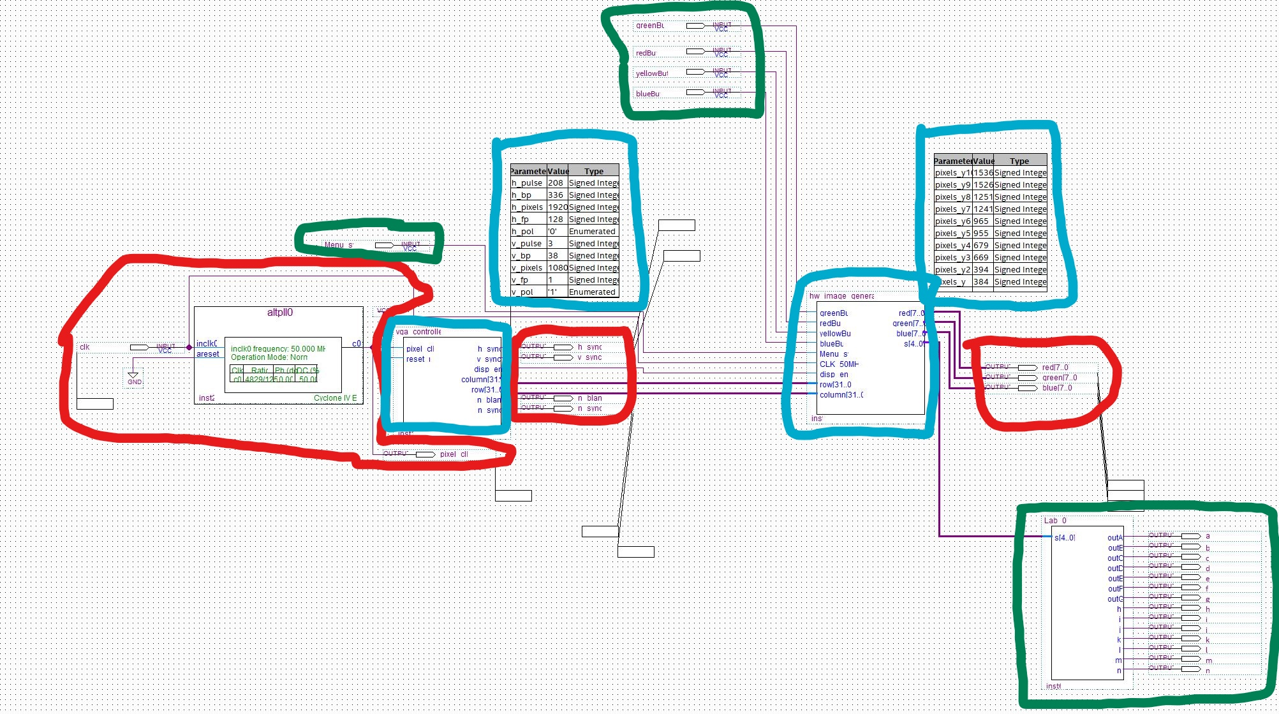

**VGA_with_hw_test_image.bdf**

If you cannot see the details of this schematic since it had to be zoomed out, you can always just compare side by side with the schematic in quartus.